Code Review: I2303234
Reviewer: James Wood
Date: June 1st, 2023
Bugs
Preventative Action/Safety
Design/Architecture (Duplication, appropriate project, namespaces, maintainability)
- Ensure that business logic is added to the correct location in the codebase. We should strive to have zero business logic behind forms. In this case, the Transfer Update logic should probably be in the WorkOrder class.
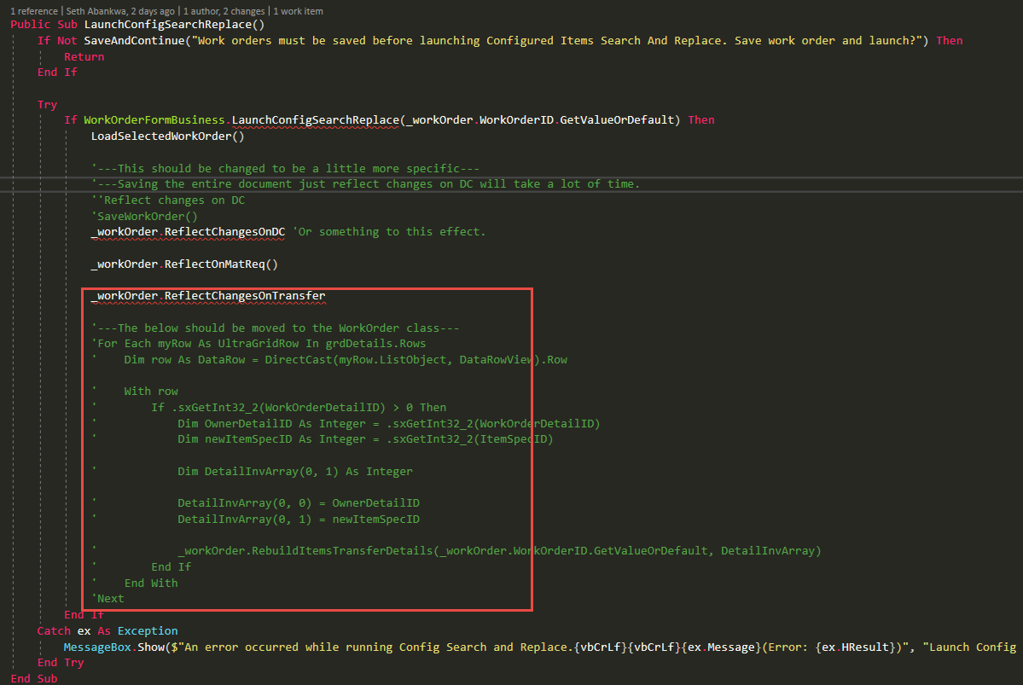
Data Model(Naming, good design, needs index?)
Performance (Minimize DB hits, excessive loops, queries, scalable)
- This image has a whole bunch of pointers, but performance wise, it seems to be calling Save on the WO document just to update DC, at least based on the comment. Is that right?
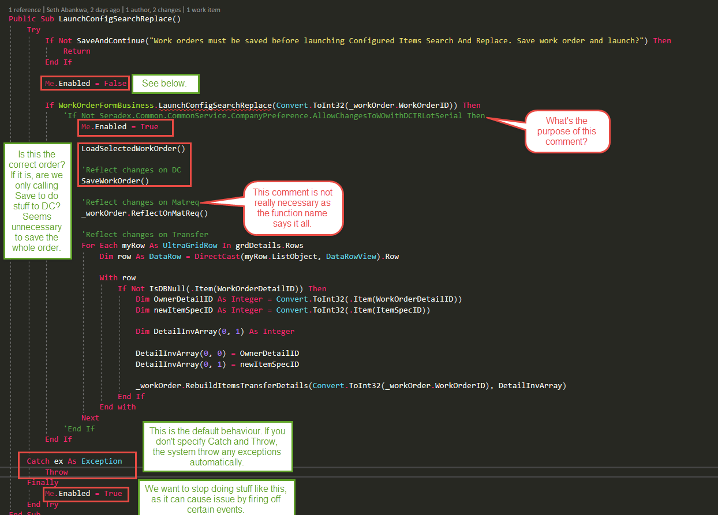
UI(Alignment, naming, standardization)
Error Handling(Behind events, appropriate parameter checking)
Cleanup (Dispose code, remove handlers, large data objects)
- There should be cleanup code for the oAutoConfig object in the error handling section, in case an unhandled error occurs in .ConfigSearchReplace(). Also, we should not be using On Error GoTo in .Net. Only use Try-Catch-Finally statements. And no Exit Function or Sub, only use Return statements.
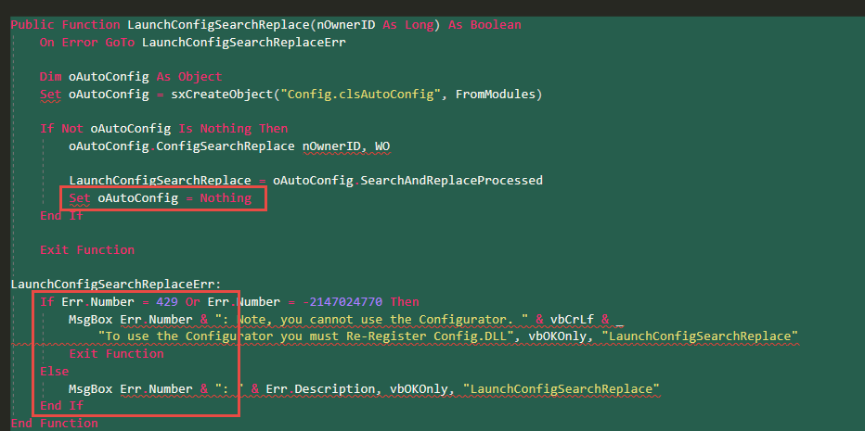
Readability (Well-named variables, methods, clear algorithm, is it understandable)
- Be sure to press Ctrl + K + D periodically while coding. This informs Visual Studio to format the code, such as ensuring proper casing for keywords and proper alignment of the code.
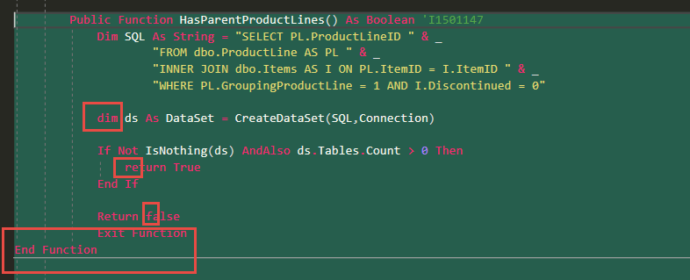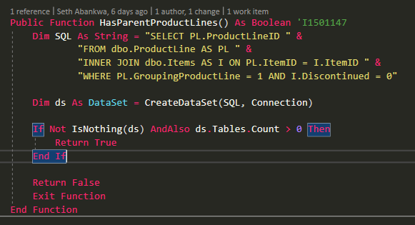
- Here’s a rewrite of the HasParentProductLines method, that contains more modern programming abilities:
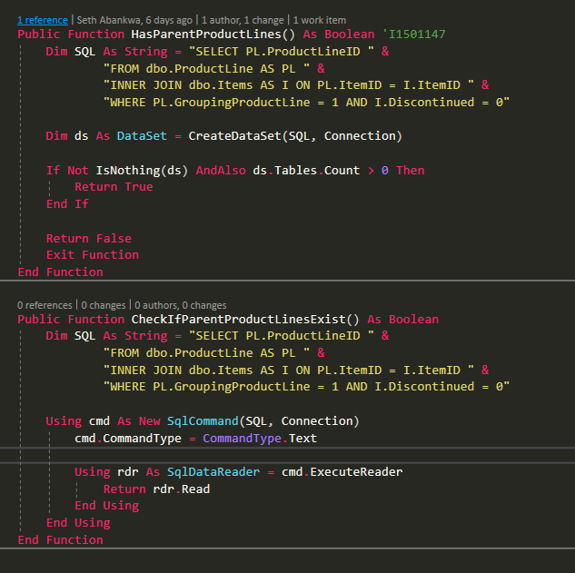
The Using clause is a very useful tool as it automatically cleans up and disposes the object for you, once it hits the End Using line.
Rdr.Read is used here instead of rdr.HasRows, because from what I’ve read, .HasRows can hide SQL errors. .Read is not super clear, but it will return True if there’s at least one line, and False if the query returns zero records.
The method name is modified, as well, as HasParentProductLines sounds like you’re checking a specific item or document, when really, it’s the entire system that’s being checked.

- Here’s a rewrite of the LaunchConfigSearchReplace method:
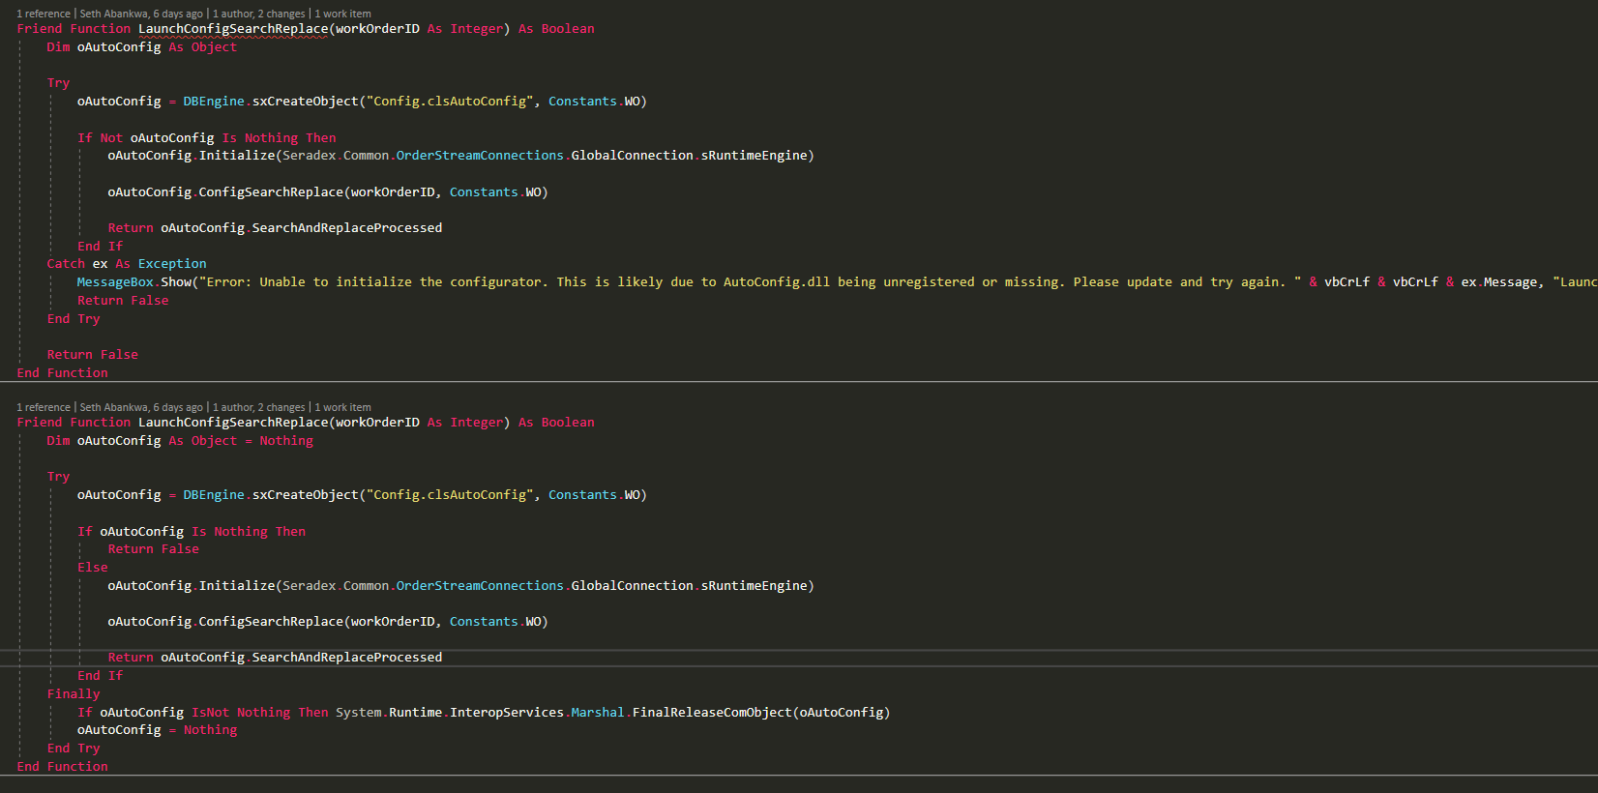
Not many changes here. I moved the Return False above so that it’s adjacent to the condition that will cause it to occur. If the AutoConfig object wasn’t properly created, then we’re done, return false, otherwise, continue with the normal processing.
Any cleanup should be done in the Finally as that will always be called whether an error occurred or not.
Also, only methods in forms should be displaying message boxes. Any methods in system classes or secondary classes should just throw the error up to the calling method/form and let that deal with the error. In this example, the message box should be moved to the calling method in the WO form.
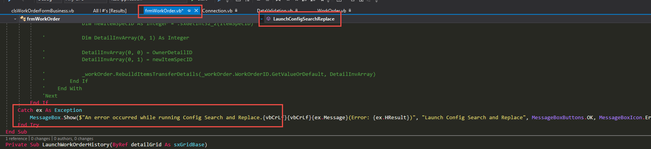
Note the use of the $ at the start of the string. This is called String Interpolation and allows easier usage of strings. Instead of having to close the quote, add an ampersand(&), reopen the quote, over and over again, just put a $ at the beginning of the string, and enclose the variable in curly braces{}.
Also, take a look at our Message Box style guide, for the proper message format. This can be found here, Y:\Documents\SOPs\Development.
- Check to see if there’s an existing method that contains code similar to what you’re adding: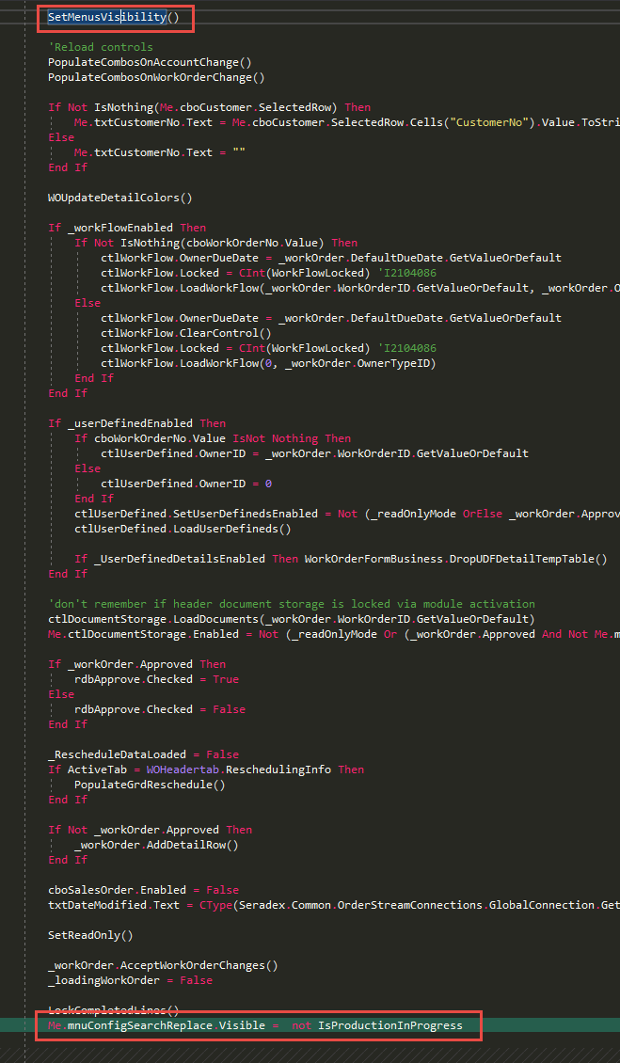
Comments (Useful, explains why rather than how)
Message Boxes (Grammar, spelling, captions, appropriate icons)
Ticket Management(Release Branch?, Testing Notes)
- Check in comments should give some details as to what was changed. It does not need to be a paragraph, but just a few sentences or so to describe the specifics of what changed.
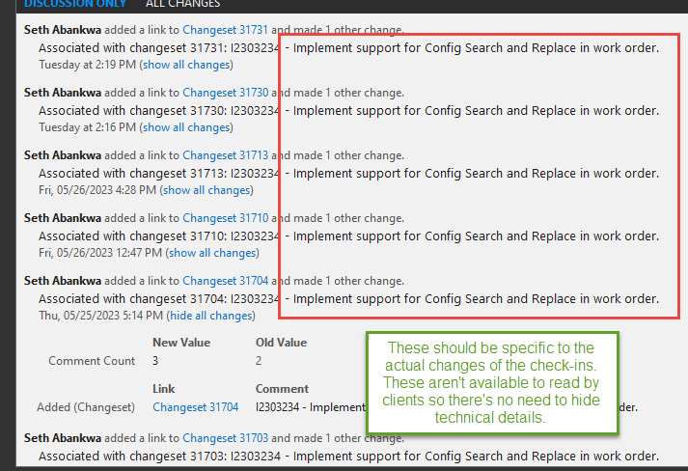
Extras
- Do not check in code that has only ever existed as non-production, commented out code.
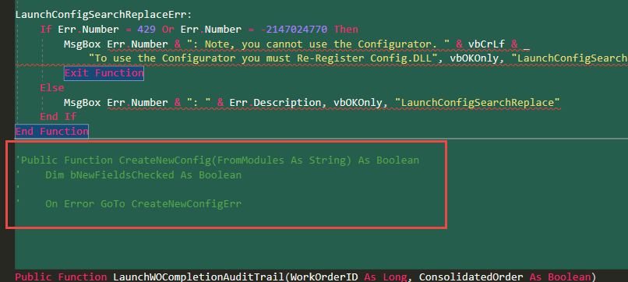
- Use Return statements in .Net instead of Exit Function or Exit Sub.
